**Number of the Experiment :** 09

**Name of the Experiment :** Implementation of Priority Scheduling Algorithm using C program.

**Date of Performance :**

**Date of Submission :**

**Aim and Objectives :** To learn about Priority Scheduling Algorithm and implement it with a C program.

**Theory :** InPriority Scheduling Algorithm,

* Priority scheduling is a non-preemptive algorithm and one of the most common scheduling algorithms in batch systems.
* Each process is assigned a priority. Process with highest priority is to be executed first and so on.
* Processes with same priority are executed on first come first served basis.
* Priority can be decided based on memory requirements, time requirements or any other resource requirement.

**Source Code :**

#include<stdio.h>

int main()

{

int bt[20],p[20],wt[20],tat[20],pr[20],i,j,n,total=0,pos,temp,avg_wt,avg_tat;

printf("Enter Total Number of Process:");

scanf("%d",&n);

printf("\n Enter Burst Time and Priority \n");

for( i=0; i<n; i++)

{

printf("\n P[%d] \n",i+1);

printf(" Burst Time: ");

scanf("%d",&bt[i]);

printf("Priority:");

scanf("%d",&pr[i]);

p[i]=i+1; //contains process number

}

//sorting burst time, priority and process number in ascending order using selection sort

for(i=0; i<n; i++)

{

pos=i;

for(j=i+1; j<n; j++)

{

if(pr[j]<pr[pos])

pos=j;

}

temp=pr[i];

pr[i]=pr[pos];

pr[pos]=temp;

temp=bt[i];

bt[i]=bt[pos];

bt[pos]=temp;

temp=p[i];

p[i]=p[pos];

p[pos]=temp;

}

wt[0]=0; //waiting time for first process is zero

//calculate waiting time

for(i=1; i<n; i++)

{

wt[i]=0;

for(j=0; j<i; j++)

wt[i]+=bt[j];

total+=wt[i];

}

avg_wt=total/n; //average waiting time

total=0;

printf("\nProcess\t Burst Time \tWaiting Time\tTurnaround Time");

for(i=0; i<n; i++)

{

tat[i]=bt[i]+wt[i]; //calculate turnaround time

total+=tat[i];

printf("\nP[%d]\t\t %d\t\t %d\t\t\t%d",p[i],bt[i],wt[i],tat[i]);

}

avg_tat=total/n; //average turnaround time

printf("\n\nAverage Waiting Time=%d",avg_wt);

printf("\nAverage Turnaround Time=%d\n",avg_tat);

return 0;

}

**Output :**

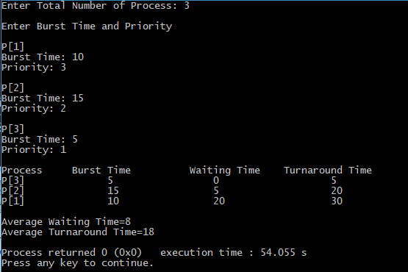

**Discussion :** Priority scheduling is a non-preemptive algorithm and one of the most common scheduling algorithms in batch systems. Each process is assigned apriority. Process with the highest priority is to be executed first and so on. Processes with the samepriority are executed on first come first served basis.